NAME JATIN KUMAR

ID 3157521

TITLE- CARGO SERVICE

# Section 1- Project planning and design

## Task 1 - Identify the problem

Client Name: Robin

Business: Cargo Service

Work to Me: Develop Software to manage data for his business

Purpose: Record Keeping

First Talk on Call:

Date: 25 October 2021

Time: 10:25 am

After we greeted each other,

I introduced myself and politely asked **Robin,**  about his business history, establishment and current day scenario about the business and I came to know from him that a decade ago he started his business and at starting his business was not to big he alone handle his business and keep al the record papers but with the time his business grown up he started facing from problems of **data mismatching, remembering the big records on paper**

I approached his decision is very good and appreciated him and then told him the benefits of being digital that how he will save his time from this and never forgot any record in future.

He told me details that which kind of software he is looking for his business that should be easy to use and maintain in future.

My solution: I told him that we will develop different tables for record keeping as earlier do to keep the record of Drivers, Parcels and Customers

Conclusion: at end we discuss to with us that we should meet once to clarify the details and requirements of the software

## Task 2 - Define and document requirements

### Scope of Work

#### The Features

The website will have following features as per requirement of the client:-

1. Mobile compatibly : Robin can use this website easily on Mobile also
2. Accessibility: Website Accessible to all user who can Login or either Register
3. Well planned Architecture of the website
4. Fast Loading of the Website
5. Effective Navigation
6. Good Error Handling
7. Secure admin pages

#### Functional or non-functional requirements that are in and out of the scope

Functional Requirements

1. *He wants customer module save update and delete and list of customers to view.*
2. *Then he wants driver module in the software.*
3. *He wants vehicle type module in the software.*
4. *He wants the record of vehicles.*
5. *He wants login and logout facility in the software.*

#### Non Functional Requirements

1. System should be portable.
2. System should be reliable.
3. System should be secure.
4. Performance of system should be good.
5. System should be flexible.

Project Deliverables –

**Time:** It will take minimum 20 days to complete. The tasks are listed as below:-

|  |  |  |  |
| --- | --- | --- | --- |
| Task | Start date | End date | Time Duration |
| Feasibility study | 22 Oct 2021 | 23 Oct 2021 | 12hrs |
| Requirement Gathering | 25 Oct 2021 | 27Oct 2021 | 16 hrs |
| Designing | 28 Oct 2021 | 3 Nov 2021 | 29hrs |
| Coding –  Login  Vehicle  Driver | 4 Nov 2021 | 9 Nov 2021 | 38 hrs |
| Testing-and Implementation | 10 Nov 2021 | 12 Nov 2021 | 11 hrs |
| Issues Solving | 13 Nov 2021 | 14 Nov 2021 | 5 hrs |

**The essential steps of the Risk Management Process are:**

**Identify the risk**: The first important task is to identify the risk factors as possible. In a manual environment, these risks are noted down manually. If the organization has a risk management solution employed all this information is inserted directly into the system. The actual risks that were identified during this situation were laptop breakdown, Poor communication with mentor/tutor, no connectivity with classmates, lack of motivation,

**Assess the risk:** To determine the severity and seriousness of the risk it is necessary to see how many businesses functions the risk affects. There are risks that can bring the whole business to a standstill if actualized, while there are risks that will only be minor inconveniences in the analysis. Covid – high risk, laptop breakdown – low possibility but high risk, Poor communication – medium risk but easy to resolve. Low risk – earthquake less likely to happen

**Treat the risk**: The problem is that the discussion is broken into many different email threads, across different documents and spreadsheets, and many different phone calls.

In covid –19 alternatives ways that came out for communication was – zoom, messenger, WhatsApp , Microsoft Teams . and many other screens sharing and inter connectivity Software’s

**Monitor and Report on the risk**: Under a digital environment, the risk management system monitors the entire risk framework of the organization. If any factor or risk changes, it is immediately visible to everyone.

**Cost:** The cost would be $1810 for this software. I am describing the whole module rate.

| **Completion based on** | **Dollar cost or units** | **hrs** | **Calculation** |
| --- | --- | --- | --- |
|  |  |  |  |
| Study | $ | 12hrs | $0 |
| Requirement Gathering | $ 15 | 16hrs | $ 15*16 =$ 240 |
| Designing | $25 | 29 hrs | $ 25*29=$ 725 |
| Coding | $ 25 | 38 hrs | $ 25*38 =$ 950 |
| Testing | $15 | 11 hrs | $15*11=$ 168 |
| Error Solving | $ | 5 hrs | $0 |
| Total |  |  | $ 2083 |
| Margin –20% | $273 |  | $1810 |

Source :-[About cost templates | Microsoft Docs](https://docs.microsoft.com/en-us/dynamicsax-2012/appuser-itpro/about-cost-templates)

**Project management: -** Project management is the science and art of organizing all the components of a project. For example, the launching of a new service, a marketing campaign, or the development of a new product are projects. In fact, even a wedding is a project that requires management.

**Waterwall methodology –**

The waterfall methodology is a project management approach that emphasizes a linear progression from beginning to end of a project. This methodology, often used by engineers, is front-loaded to rely on careful planning, detailed documentation, and consecutive execution.

Benefits of this methodology:

Developers can catch design errors during the analysis and design stages, helping them to avoid writing faulty code during the implementation phase.

The total cost of the project can be accurately estimated, as can the timeline, after the requirements have been defined.

**Source:** https://www.workfront.com/project-management

Gantt chart – stay on track, monitoring

Task Planner

Week 4

Week 3

Week 2

Week 1

**Tasks**

Study

Requirement Gathering

Designing

Coding

Testing and Implementation

Color Schema :

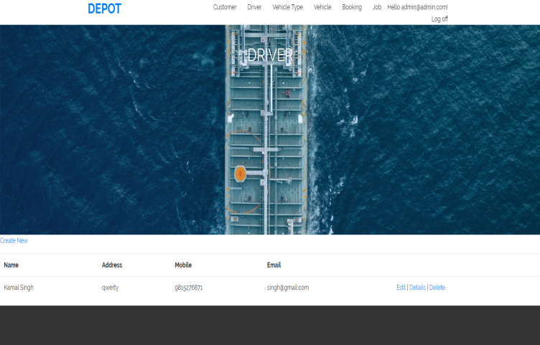

White background black blue text

Blue Background white Text

Black Text and White Background

## Task 3 - Design mockups

## 

## 

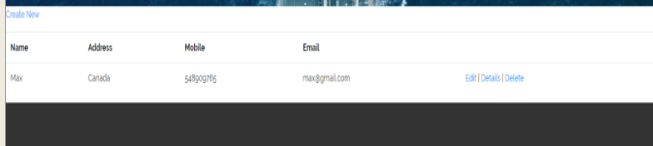

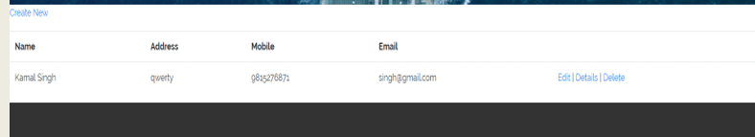

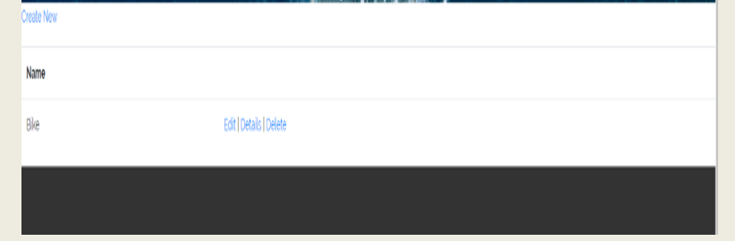

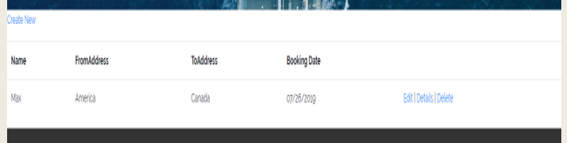

# Section 2 – Project development- find the project code in folder

## Task 4 – Coding

**1. Register Page: - This** is Register page in where you can register new user

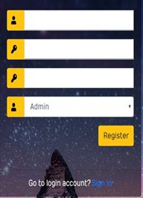

**2.Login Page: -** This is Login page of our website. In this page I can login as a Admin oras a Manager.

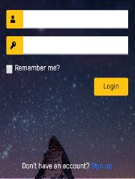

**3. Admin Login**: When admin logins then he can access the all modules of website. Which are shown in the picture.

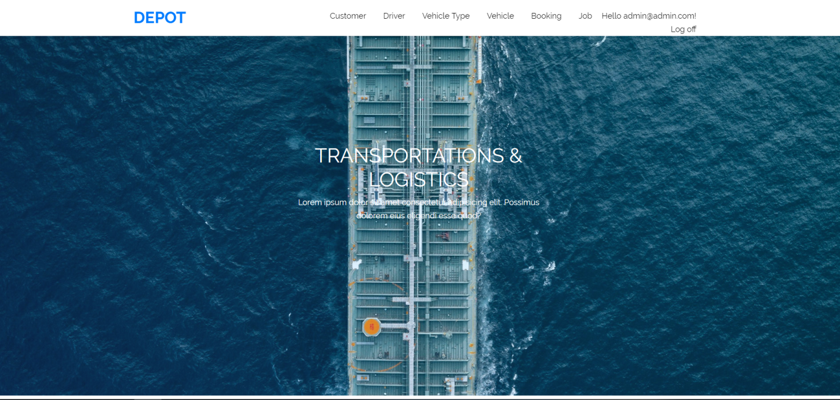

**4. Customer: -** Here I can show the customer in my website. And clicking on the create new link I can create the customer. Edit and delete customer are also available here.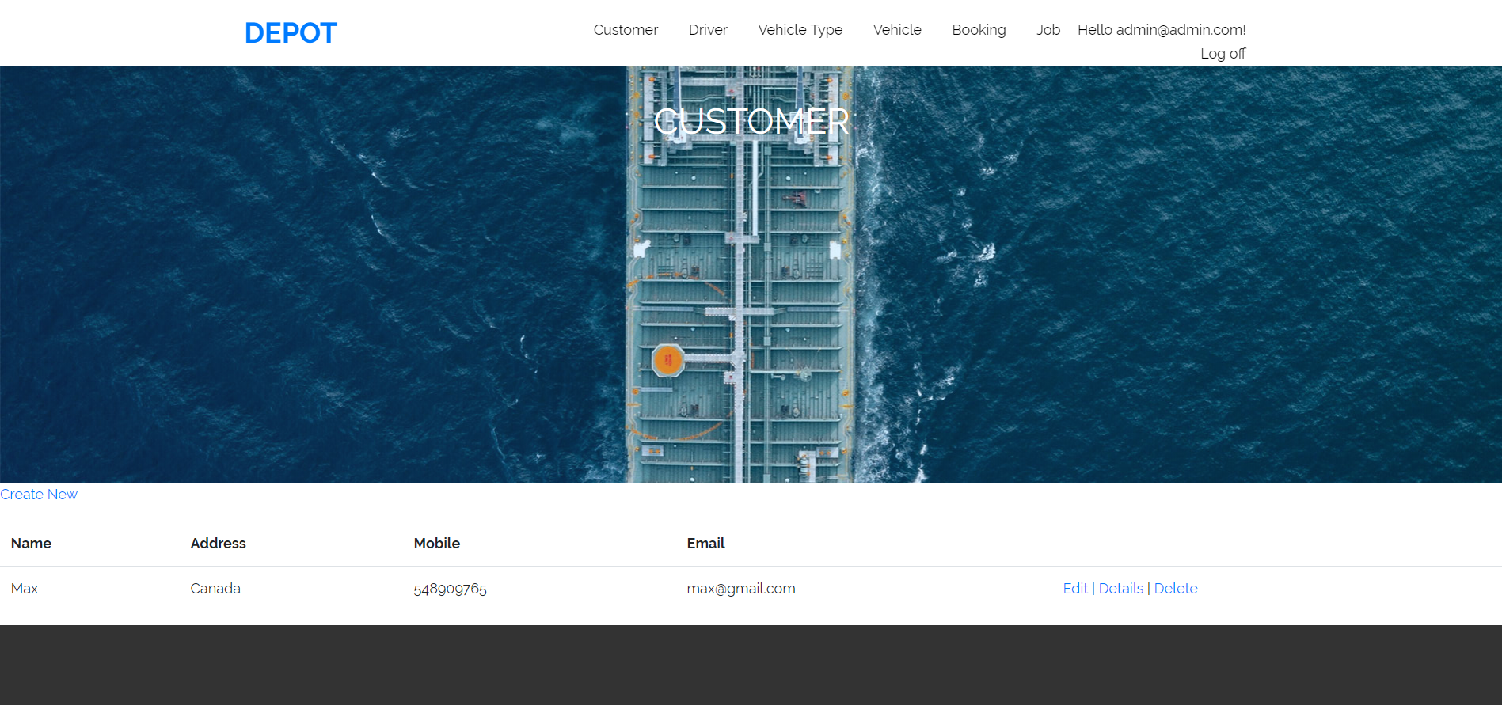

**5. Driver: -** Here I can show the driver in my website. And clicking on the create new link I can create the driver. Edit and delete driver are also available here.

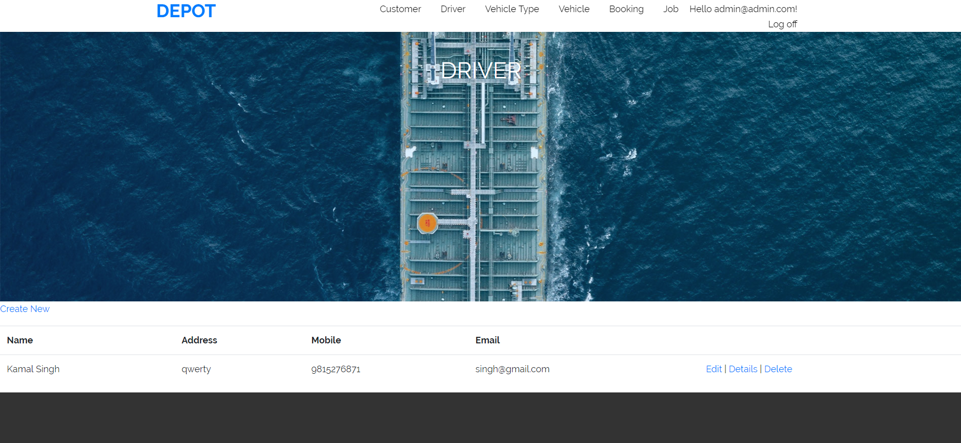

**6. Vehicle Type: -** Here I can show the vehicle type in my website. And clicking on the create new link I can create the vehicle type. Edit and delete vehicle type are also available here.

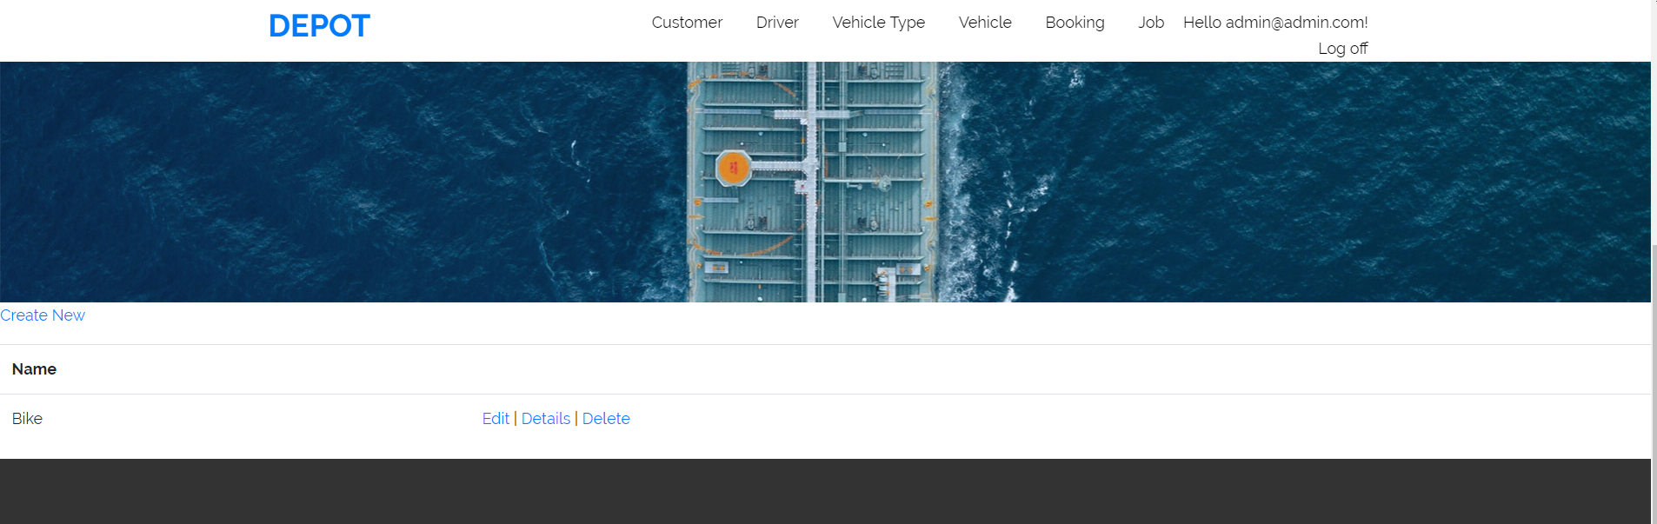

**7. Vehicle: -** Here I can show the vehicle in my website. And clicking on the create new link I can create the vehicle. Edit and delete vehicle are also available here.

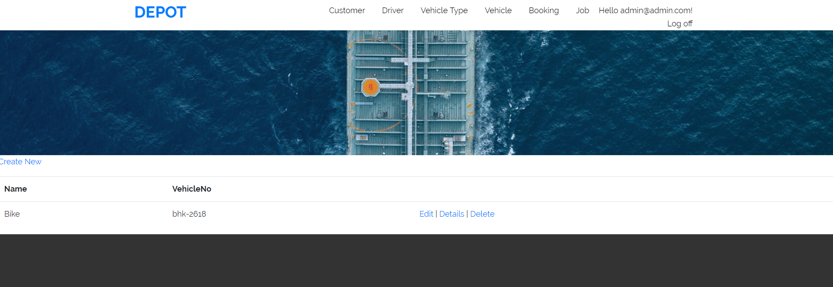

**8. Booking: -** Here I can show the booking in my website. And clicking on the create new link I can create the booking. Edit and delete booking are also available here.

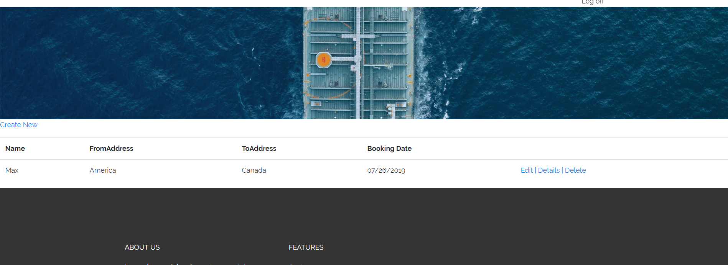

## Task 5- usability testing

On excel File

## 

## Task 6 - Meet with your client

|  |
| --- |
| Meeting Details |
| * Date and time: 25-Oct-2021 * Location: New Zealand |
| Attendees: Jatin and Robin |
| Agenda: Discussion of Software of Cargo services |
| Discussion (Important Points): He needs customer and booking module on the highest priority. Left requirement is written on above. |
| My To Dos (Actions): Firstly I have to make the mock-ups of the application. Then Starting the application after the next meeting. |
| Questions requiring Follow- Up: Discussion of the mock ups |
| Comments: Robin is good person and he described regarding software very wisely. |
| Next meeting  Date and Time: 1- Nov-2021 1:00 Pm  Location: New Zealand  Agenda: Showing the mock ups to the client and discussion about further development. |

**Appendix 3**

**Client Review Form**

My developer’s name: Jatin

This form is intended to let you review the communication skills of your developer for this assignment. Your review will partly count towards their final mark. Do not take into account technical skills.

# Grading scale

You must grade your developer for each item listed in the tables below. 1 being the lowest, 5 the highest.

|  |  |  |  |  |
| --- | --- | --- | --- | --- |
| **1** | **2** | **3** | **4** | **5** |
| Strongly disagree | Disagree | Ok | Agree | Strongly agree |

# Review your developer

|  |  |  |
| --- | --- | --- |
| **Item** | **Grade** | **Comment** |
| Communicated clearly and effectively | 2 |  |
| Kept you informed of the progress | 5 |  |
| Met timelines | 4 |  |
| Responded promptly to problems | 3 |  |
| Met overall project objectives | 1 |  |
| Was open to new ideas and suggestions | 5 |  |
| Was easy to work with | 5 |  |

Comments

Provide any extra comments on your developer’s communication skills and professionalism.

Jatin is good developer. He is very good in his work. I proud to get my work completed by jatin.

## Signed by Client

|  |  |
| --- | --- |
| **Signature: Robin** | **Date: 13-nov-2021** |
| **Name: Robin** | **Title:Cargo Services Software** |
| **Contact details (email/Tel):** | |

# Section 3– Presentation and reflection

## Task 7- Presentation

PPT attached in documentation Folder

## Task 8 - Software development life cycle

SDLC is a process followed for a software project, within a software organization. It consists of a detailed plan describing how to develop, maintain, replace and alter or enhance specific software.

### Planning

Requirement analysis is the most important and fundamental stage in SDLC. It is performed by the senior members of the team with inputs from the customer, the sales department, market surveys and domain experts in the industry

In my project, during our first meeting I got initial requirements from the client about his needs regarding to the project and given suggestions to the client for betterment of the website

### Requirement

Once the requirement analysis is done the next step is to clearly define and document the product requirements and get them approved from the customer or the market analysts. This is done through an SRS (Software Requirement Specification) document which consists of all the product requirements to be designed and developed during the project life cycle.

In the second meeting: I showed mockups of the website to the client that were discussed in the first meeting and planned about the upcoming things that were left on the website and I created to do list

After the meeting I started working on the left task and completed and marked as done from my to-do list.

Software design and prototyping: As per requirements I designed the software so that client did not require much training for running this software. Prototyping is used to allow the users evaluate developer proposals and try them out before implementation. It also helps understand the requirements which user are specific and may not have been considered by the developer during product design.

Software Development: at this stage I started building software with the coding standards and I follow the guideline and I develop this software using Visual Studio.

# Testing:

The testing module comes in all stages of SDLC and is very important as tested this software with all testing guidelines and tracked all the issues and then restored them until product reaches to the quality.

## Quality –

It is very difficult to carry such a complex software without the team efforts but with help of SDLC we can create quality software here. It is a kind of framework that is used to develop a software. There are methods to, but this is best and better way to develop software.

## Task 9- Project management

### Introduction –

The starting point in discussing how projects should be properly managed is to first understand what a project is and, just as importantly and what not to do General things about designing and developing should be take care in mind and People have been undertaking projects since the earliest days of organized human activity

### Weakness-

The hunting parties of our prehistoric ancestors were projects, for example, they were temporary undertakings directed at the goal of obtaining meat for the community. Large complex projects have also been with us for a long time.

### Success-

The pyramids and the Great Wall of China were in their day of roughly the same dimensions as the Apollo project to send men to the moon.

### Lesson learned –

We use the term “project” frequently in our daily conversations. A husband, for example may tell his wife, “My main project for this weekend is to straighten out the garage.” Going hunting, building pyramids, and fixing faucets all share certain features that make them projects. So, I have learnt many things from this project. I never think a lot of knowledge with project work I can get in software. Now I can get job in IT easily.

### Quality -

A project has distinctive attributes that distinguish it from ongoing work or business operations. Projects are temporary in nature. They are not an everyday business process and have definitive start dates and end dates. This characteristic is important because a large part of the project effort is dedicated to ensuring that the project is completed at the appointed time. To do this, schedules are created showing when tasks should begin and end. Projects can last minutes, hours, days, weeks, months, or years.